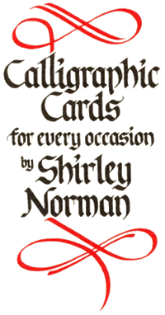
MAIL ORDER FORM
JANUARY 2013

NAME ___________________________________
ADDRESS ____________________________
__________________________________________
____________________________________
____________________________________
POST CODE __________________________
TELEPHONE __________________________
EMAIL ______________________________

TERMS OF TRADING
Payment in full with all orders. Please ensure the correct postage is added on to the cost of the cards : see overleaf. Prices are held for three months – please check thereafter. Claims for shortages or damaged cards can only be considered if notified in writing within five days of receipt. Goods cannot be accepted for exchange or return.
Please allow twenty one days for delivery.
Calligraphic Cards are sold to the customer on the understanding and condition that they will not be offered for resale.

PAYMENT
By Cheque: Please make cheques payable to Calligraphic Cards and send to:
Calligraphic Cards, 2 Holbrook Close, Broad Haven, Haverfordwest,
Pembrokeshire. SA62 3JE. UK. Payment of accounts must be made
within 30 days from date of invoice. Reminders incur a £10 charge for
each reminder.

By Credit/Debit Card: we accept Visa and Mastercard with the following details:

CARD NUMBER__________________________________________
START DATE _____________EXPIRY DATE _____________
CARD SECURITY CODE _______________
CARDHOLDER’S ADDRESS TO WHICH CREDIT/DEBIT CARD
STATEMENTS ARE SENT ____________________________
_________________________________________________
CARDHOLDER’S POSTCODE __________________________
TELEPHONE NUMBER AT ABOVE ADDRESS ______________

Contact details: Shirley Norman, Calligraphic Cards, 2 Holbrook Close,
Broad Haven, Haverfordwest. Pembrokeshire. SA62 3JE. UK.
Telephone: 01437 781775. Email: Scribe@CalligraphicCards.co.uk
Web: www.CalligraphicCards.co.uk

